Name of Mobile Application: AB Direct
Existing UI Issues:
- Account Number Visibility: In the old UI, sensitive information like full account number is shown by default, which may create privacy risks in public use; redesigned UI hides these information and displays only limited details.
- Clarity and Visual Hierarchy: Existing UI presents balance information, shortcuts and promotional banners with similar visual weight which reduces clarity and weakens hierarchy; redesigned UI clearly highlights the account card and balance section at the top and separate other sections properly.
- Simplicity and Minimalism: The old UI contains too many sections and options on screen which makes it visually overwhelming; redesigned UI removes unnecessary options and groups features into categories.
- Consistency and Navigation Structure: In the previous UI, multiple sections are combined without a clear structure which may confuse users; redesigned UI maintains a consistent navigation bar and clearly labeled primary sections.
- Task Focus and Efficiency: Existing UI contains a large promotional banner that distracts users from primary banking tasks; redesigned UI reduces the size of the advertisement section which helps users focus properly on banking activities.

UI Redesign: Attached in
‘240042148_assignment_2_UI_design.pdf’ file.

Justification of Improved Usability:
The redesigned user interface significantly improves usability by decreasing visual clutter and showing only the most important functions on the home screen. Home screen navigation is now more simplified through a consistent and clearly labeled bottom navigation bar that remains stable across sections. Important information such as account number, account balance and primary actions are displayed at the top which allows users to access them easily. The new layout follows a clean and structured hierarchy that reduces unnecessary load and improves content scanning. By applying the basic usability principles of simplicity, consistency, visibility and minimalism, the redesigned user interface improves efficiency and overall user experience.
User Interface Evaluation Chart:
The evaluation was conducted with a sample size of 10 users via Google Forms. The chart of old UI and redesigned UI evaluation are shown below:
• Old UI Evaluation:
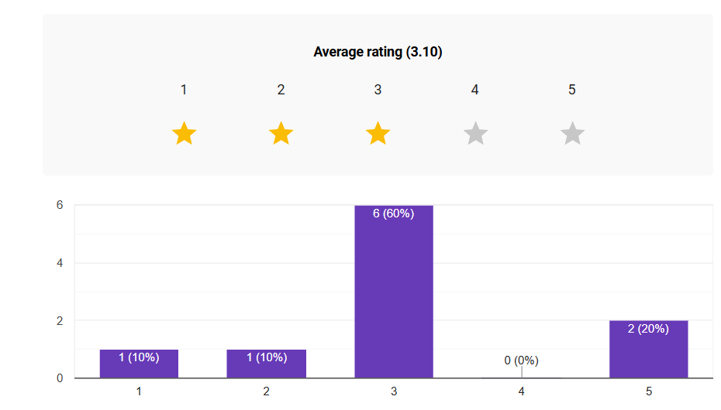
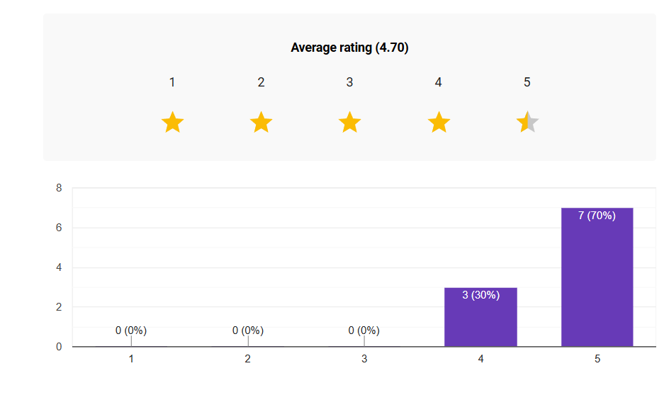
• Redesigned UI Evaluation:
From the charts above, it is seen that the old user interface received an average rating of 3.10, while the redesigned user interface achieved an average rating of 4.70. This indicates a clear improvement in user satisfaction with the redesigned interface compared to the old one. Therefore, it can be said that the redesigned user interface is more accepted among users, providing more friendly and convenient app experience.

